**Web Face: Elevating Web Authentication with Facial Recognition Technology**

**Sai Chandu Naladala**

**Sai Sushank Manthri Pramod**

**Advitha Bawgi**

**Sakshi Surendra Ambadkar**

**IFT 520: Advance Information System Security**

**Information Technology, Arizona State University**

**Dr. Jim Helm**

**November 28, 2023**

**Table of Contents**

|  |  |
| --- | --- |
| **CHAPTER** | **Page No** |
| 1. Abstract | 4 |
| 2. Introduction | 5 |
| 3. Design Process  3.1 Requirements  3.2 Functional Requirements  3.3 Non-Functional Requirements  3.4 Scope | 7  7  8  9  10 |
| 4. Development Process  4.1 Tools  4.2 Technical Description  4.3 Working Flow  4.4 Appendix | 12  16  17  19  23 |
| 1. Testing   5.1 Scope  5.2 Application Overview  5.3 Testing Environment  5.4 Testing Plan | 27  27  27  27  28 |
| 6. Results  6.1 Recommendations | 33  36 |
| 7. Summary and Conclusion | 37 |
| 8. References | 40 |
| 9.List of apendices |  |

**ABSTRACT**

This development project brings an innovative approach to web authentication by using face recognition technology combined with the features of the Flask module. By using the unique biometric characteristics of the face, the initiative aims to enhance user safety and ease of online interactions. The solution uses a multi-modal approach to combine the scalability of Flask with the flexibility of the face recognition algorithm to make it easy to integrate into the online applications. Test results demonstrate how well the Web Face authentication works in the real world, including the identification and verification of users.

By integrating Flask into the Face recognition module, web apps communicate with the system and provide a smooth user experience. A stronger authentication process is made possible by the system’s resistance against common security threats. For the project’s deployment, it is recommended to conduct ongoing privacy assessments, make frequent changes to the face recognition model to accommodate facial recognition technology development, and provide comprehensive user education about the system’ capabilities and limits. It is also recommended to consult with cybersecurity specialists to further evaluate and enhance the defense against any new security threats.

To sum up, the overall conclusion is that the Web Face project merges the functionalities of the Flask module with face recognition to advance web authentication technologies. The findings highlight ways to improve user authentication experiences and provide recommendations for safe and effective system implementation.

**INTRODUCTION**

In today’s world, where digital interactions dominate the day-to-day, web authentication techniques must be secure and user-friendly. Cyber threats are becoming increasingly sophisticated and use traditional authentication methods such as passwords or PINs to gain access to sensitive information. The “Web Face” project is a pioneering initiative that aims to enhance web authentication by combining facial recognition with the flexibility offered by the Flask module.

**Background:** With the growing popularity of online services and the ever-expanding digital landscape, cyber threats have increased dramatically. While password authentication was once considered secure, it has now become vulnerable to a variety of security vulnerabilities, including password reuse, brute force and phishing attacks. In this context, face recognition biometrics have attracted attention due to their ability to provide a more convenient and secure alternative.

**Problem Statement:** The limitations and shortcomings of traditional authentication systems necessitate innovative solutions. The demand for a simple, reliable, and secure web authentication system is on the rise, and this project seeks to meet that demand. The integration of facial recognition technology is designed to overcome the shortcomings of traditional approaches by offering consumers a secure and convenient way to authenticate online.

**Framework:** The Web Face project adopts a two-pronged approach that combines cutting-edge face recognition technology with the scalability and scalability of the functionalities of the Flask module. A complex model is trained on a wide range of datasets to achieve face recognition. Face recognition relies on the uniqueness of the facial features for identity verification. The interface that seamlessly integrates the facial recognition module in online applications is built using the microweb framework, Flask, which is a Python-based framework for microweb development. The framework makes the system easier to use and ensures that it can be adapted to various online environments.

**Nature of Work:** To finish the project, we need to develop a sophisticated face recognition model that will be able to accurately identify and verify users in real time. In addition, the integration of the Flask module functionality requires the development of a straightforward and user-friendly web application interface. This makes it easier to adopt facial recognition technology across various online platforms.

**Study Significance:** This research is important because it has the potential to completely change the way we authenticate online. Web Face offers a secure and practical alternative to traditional authentication methods by combining the benefits of face recognition with the functionalities of a Flask module. Not only does this initiative address current security challenges, but it also presents itself as a forward-thinking solution that can adapt to the ever-evolving demands of the digital age. This study's findings are expected to significantly impact the conversation surrounding biometric authentication, paving the way for better user experiences and stronger cybersecurity in the digital world.

**3. DESIGN PROCESS**

**3.1 REQUIREMENTS**

The primary objective of the “Web Face” project is to integrate facial recognition with the Flask module to redefine web authentication. The goal of this project is to improve both user safety and user experience in online transactions. To understand the project's requirements, it is necessary to look at both the technical and functional necessities.

**Technological Demands:**

**Hardware Essentials:**

For accurate face capture, you’ll need top-of-the-line cameras, whether they’re high-quality external cameras or front-facing cameras built into your mobile devices. Server infrastructure and cloud environments are essential for handling computational workloads and storing the massive amount of user data. GPU integration is essential to speed up the inference and training stages of your deep learning models. You’ll also want to make sure you have enough storage capacity to effectively protect your user data.

**Software Components:**

The development path is based on a collection of web development tools, including HTML, CSS, and JavaScript, and an excellent framework such as React, Angular, Vue.js, etc. Integration of third party APIs (e.g. geolocation services, communication verifications such as emails or SMS) improves the functionality of the system. Developing an easy-to-understand and engaging UI and experience design is essential. Strong user education is equally important to ensure clear understanding of system functionality and privacy settings among users.

**3.2. FUNCTIONAL REQUIREMENTS:**

**System Development:** The front-end development focuses on creating a user-friendly interface that simplifies the registration and login process. The system uses JavaScript to capture facial data through the device’s camera while providing a simple display mechanism. The back-end development includes building a Flask server, using the Face net model to extract facial features, managing the user registration and login process, running database operations, and including image processing and storage functions.

**Facial Recognition:** The facial recognition phase is the most important part of the system development process. Training the facial image model with facial data sets is essential for reliable real-time identification. Matching algorithms are used to verify users based on facial features and set thresholds to minimize false positives and negatives.

**Database management and security measures:** It is essential to create a secure database to store user profiles and facial feature representations while running operations for data management. Encryption protocols and strict access controls are essential.

**User Experience and Privacy Focus:** Streamlined, easy-to-use registration and login processes, with clear instructions during facial image capturing, are essential. Providing alternative authentication paths in case of recognition issues is critical. Exclusive consent and a strong commitment to privacy policies detailing data collection, storage and security measures are key components of this project.

**3.3. NON-FUNCTIONAL REQUIREMENTS:**

**1. Performance:** The system should respond quickly during face-to-face capture, face-recognition, and authentication to ensure a seamless experience for users. The architecture of the system should be flexible enough to support an increasing number of users without sacrificing performance.

2. **Reliability:** Ensure consistent availability of the system for users to access authentication services. Have robust mechanisms in place to gracefully manage any errors or failures that may occur during the facial recognition process.

3. **Security:** Ensure that all user data, including facial templates and personally identifiable information, is securely stored and transmitted. Have role-specific access control mechanisms in place to limit access to the system based on the role of the user, such as an administrator or a regular user.

4. **Maintainability:** Have a well-structured, documented, and modular code base to support future improvements, bug fixes, and upgrades. Have comprehensive documentation covering the system architecture and APIs, as well as reference and maintenance guides.

5**. Compliance and Ethics:** Maintain strict compliance with privacy regulations governing the collection, storage, and use of facial data, while maintaining transparent communication about the usage of data and system capabilities. Have clear consent mechanisms in place to ensure ethical standards are adhered to.

6. **Performance Monitoring:** Have monitoring tools in place to monitor system performance, detect irregularities, and collect usage analytics for continuous improvement.

**3.4. SCOPE**

**User Registration**: The system allows users to register by capturing unique facial data that is securely stored for future verification. This creates a unique way for users to create accounts and increases overall security.

**User Authentication:** Users are authenticated using sophisticated facial recognition technology, which compares captured facial features at the login stage to pre-existing profiles to confirm identity.

**Error Handling & Feedback:** The system provides precise guidance and feedback during facial data capture and user authentication processes to ensure a smooth user experience by providing clear instructions and efficient error management, especially in recognition failure cases.

**Security and privacy:** Strong security measures are in place to protect server infrastructure and user data, especially facial templates. Privacy regulations require explicit consent for handling and storing user data.

**User Administration:** Management tools are in place to help administrators manage user accounts and access privileges, as well as manage various authentication methods in the system.

**Scalability & Efficiency:** This system is designed to handle an increasing number of users while still maintaining authentication efficiency.

**Training & Documentation:** Comprehensive training and documentation are provided during system implementation to help administrators and users understand how to use the system, streamlining the adoption process.

**Maintenance & Monitoring:** Monitoring tools actively detect system issues and address them quickly. Regular upgrades and maintenance routines are key to keeping the system running smoothly and meeting performance and security standards. Disaster Recovery & Backup: Backup protocols are in place to ensure data recovery in the event of an unforeseen system failure or data loss. This ensures data continuity and minimizes the risk of long-term data loss.

**4. DEVELOPMENT PROCESS**

The first step in the development process is to carefully plan and select the right technology for the project. The next step is to integrate face_recognition to enhance facial recognition capabilities. The next stage is to use the web functionality of Flask. The HTML templates demonstrate how the UI is designed to be easy to use and clear for the user. The users can input photos to the system for facial recognition and access is granted according to the results of the comparison. Security protections are implemented to improve the user experience and protect against attacks.

The design's ability to adapt to different screen sizes is highlighted throughout the process. Besides authentication, the system also provides instructional material on web security to encourage safe online conduct. Future goals may include further security improvements, expansion of instructional material, and UI enhancements. In conclusion, the development process demonstrates how innovative application of technology can create a secure, efficient, and easy to use facial recognition web authentication solution.

|  |  |  |
| --- | --- | --- |
| **View_Cell** | **Title** | **Description** |
| 1 | Overview of Project | Web Face is enhancing web authentication with facial recognition using Flask and face_recognition. |
| 2 | Authentication Flow | Users start facial recognition by uploading an image. The submitted photo is compared to a recognised face by the application. Access is granted for successful matches; it is denied for unsuccessful matches. |
| 3 | Validation of File | Safe file handling: We only accept JPG, PNG, and other valid file formats. Friendly error messages are triggered by invalid files. |
| 4 | User Interface | Responsive design combined with an easy-to-use interface. offers a smooth experience with aspects that are aesthetically pleasing and unambiguous authentication results. |
| 5 | Welcome Page | When authentication is successful, users are sent to a welcome page that validates their access to the protected online environment. |
| 6 | Handling of Errors | In the event that an authentication attempt fails or a file upload is invalid, users are gracefully redirected to an error page with explicit instructions. |
| 7 | Security Measures | Flask and face_recognition highlight security. The additional layer of identification provided by facial recognition improves security in general. a |
| 8 | Background Images | Having visually appealing backdrop graphics improves the user interface's visual appeal while preserving a polished atmosphere. |
| 9 | Responsive Design | Responsively designed to provide a unified and intuitive user experience on a range of platforms, including smartphones and desktop computers. |
| 10 | Project Title and Purpose | entitled "Web Face: Elevating Web Authentication with Facial Recognition Technology." explains how to integrate facial recognition technology for increased security. |
| 11 | Educational Content on Web Security | A secure online environment is promoted by the informative web security information on the welcome page, which encourages users to keep up with the newest security procedures. |
| 12 | Conclusion and Future Development | Summarizes the project and makes recommendations for future work, including improving the user interface, adding more instructional materials, and adding more security features. |

**4.1. TOOLS**

We use two essential components in the creation of our facial recognition online authentication solution: face_recognition library the web framework flask for face recognition. Since it manages routes, handles file uploads and displays dynamic HTML templates, it acts as the foundation for online applications. Much like a house’s foundation, it’s robust and simple. Flask is used in combination with face_recognition, which simplifies the complex world of facial recognition. Developers can easily add advanced facial recognition features to the system by using this tool. Both works together to ensure that our web authentication solution is efficient, secure, and user-friendly, thus maximizing the user experience.

**4.2. TECHNICAL DESCRIPTION**

1. Installing and configuring the Flask framework for the web application. Defining the authentication routes (/authenticate) and the home page (/).

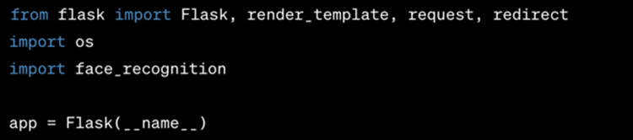

2. Facial Recognition Initialization: First, we use face_recognition to determine the face encoding of a well-known face image. Then, we compare the uploaded image with this well-known encoding.

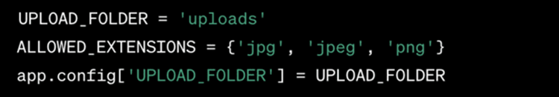

**3. Verifying the file:** The uploaded file's validity as an extension is verified by the allowed_file function.



**4. Routing to HTML web pages:** The HTML templates for uploading an image is rendered by the home page route ("/").

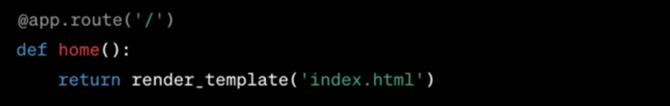

5. **Routing of Authentication:** ("/authenticate") manages the upload of images, stores the file, and applies facial recognition to the uploaded images.

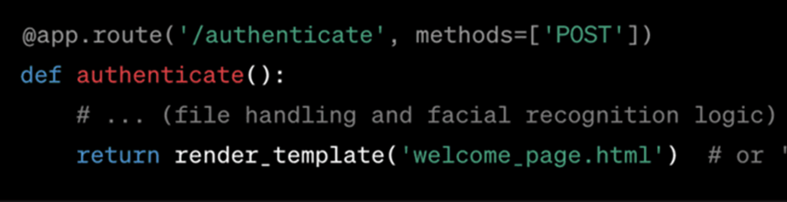

6. **Launch the Programme:** Lastly, if the application is started as the primary programme, it operates in debug mode.



**4.3. WORKING FLOW:**

**1. Executing Code:** After we execute app.py file, a URL is generated for accessing our web pages.

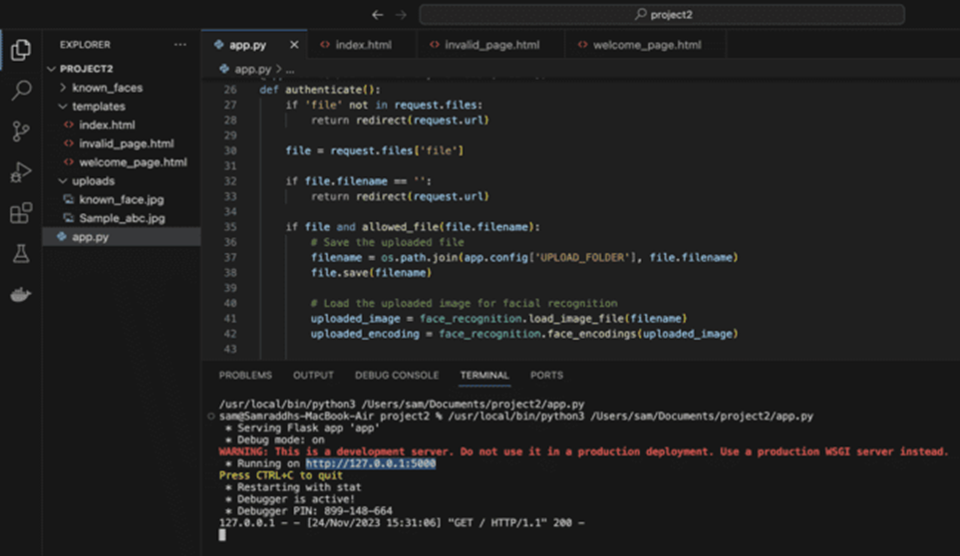

**2. First Module:** index.html page opens which is basically the front page of the project and it is seeking for the image that needs to be uploaded to check for the authentication of the end user.

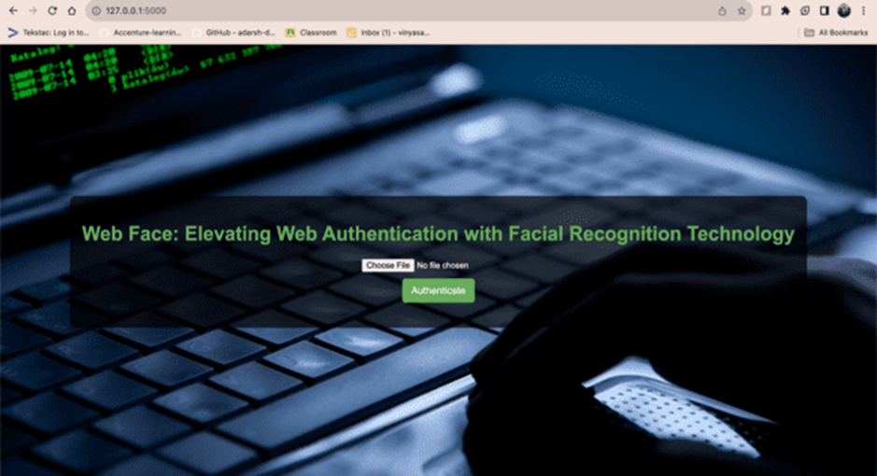

**3. Validating Image:** If the image matches with the unique image entered into the system then the access will be given and the welcome page will open or else it will be redirected to the invalid file page.

**Case 3.1: Invalid Image:**

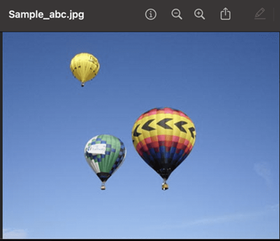

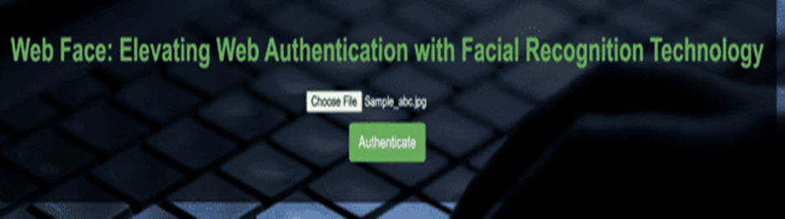

**4. Second Module:** As we entered the wrong image thus we are redirected to the invalid webpage.

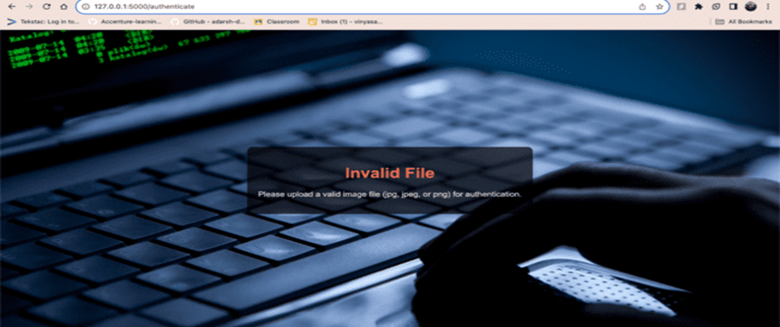

**Case 3.2: Valid Image:**

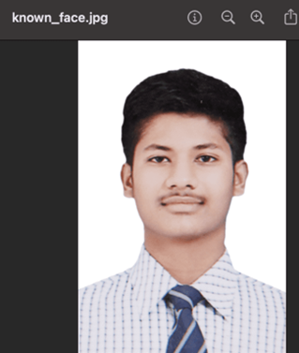



**5. Third Module:** As the image uploaded matches with the image entered into the system, thus we are redirected to the welcome page as access has been granted to the user.



**4.4. APPENDIX**

**1. app.py (Python file)**

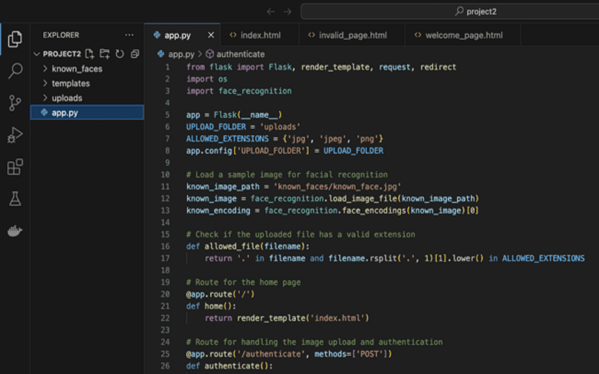

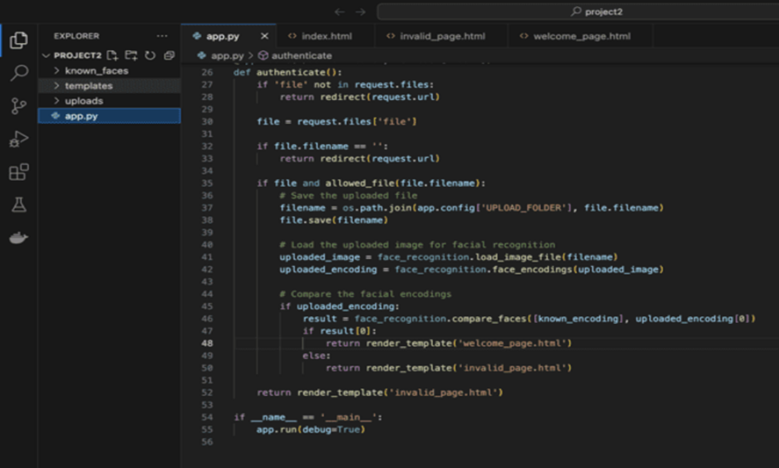

**2. index.html**

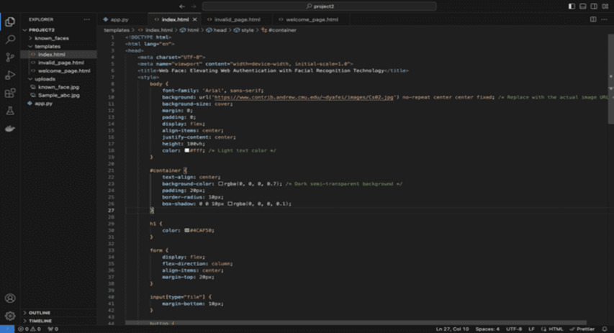

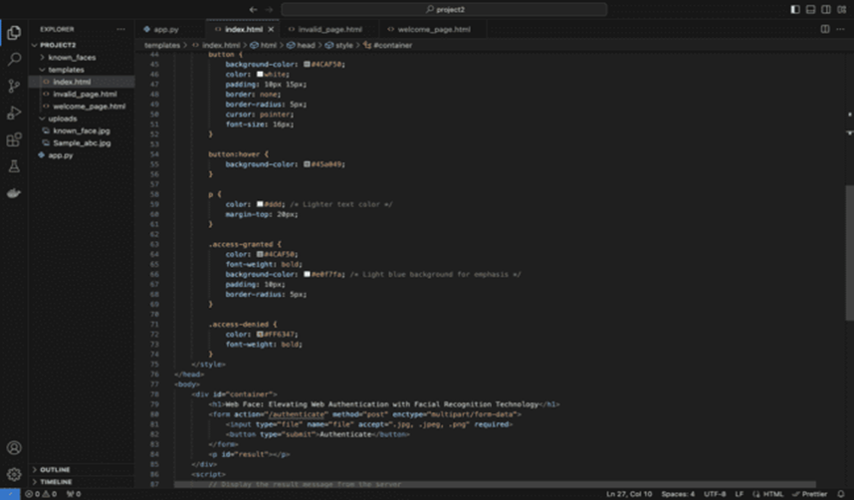

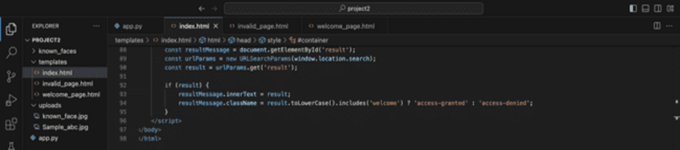

**3. invalid_page.html**

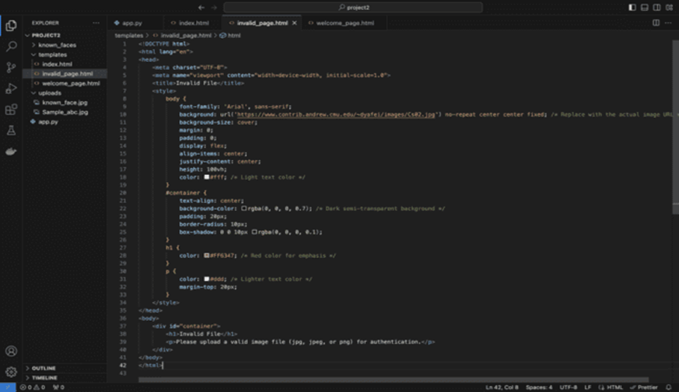

**4. Welcome_page.html**

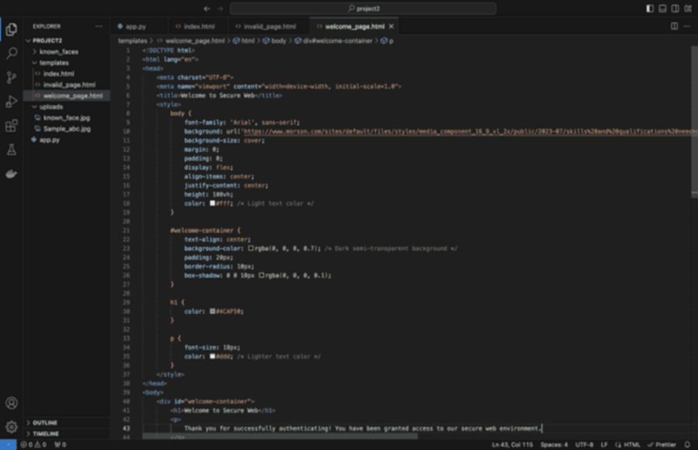

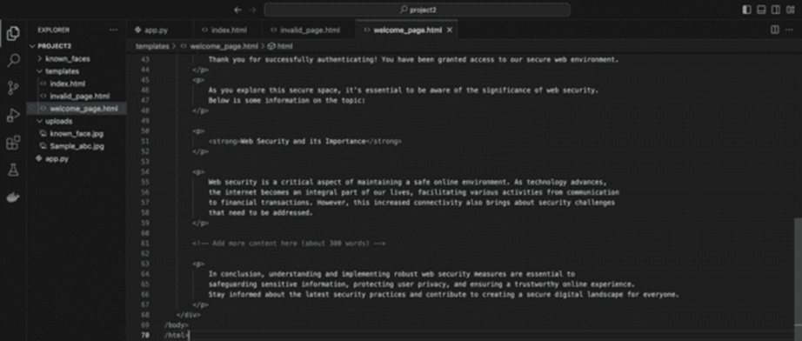

**5. TESTING**

**5.1. SCOPE**

The tests focus on the functionalities of the Flask app, such as file upload, face recognition, and redirecting users.

**5.2. APPLICATION OVERVIEW**

**Technology Stack:**

* Flask
* face_recognition library

**Key Functionality:**

1. The user uploads an image

2. The facial recognition algorithm compares the uploaded image to a known face

3. Based on the facial recognition results, the user is redirected

**5.3. TESTING ENVIRONMENT**

**Development Environment:**

* OS: Windows 10
* Python Version: 3.8.5
* Flask Version: 2.1.0
* face_recognition Version: 1.3.0

**Dependencies:**

* Ensure all required dependencies are installed using `pip install -r requirements.txt`.

**5.4. TESTING PLAN**

**1. Home Page Access**

Test Steps:

* Access the home page at `http://localhost:5000/`.

Expected Result:

* The home page (`index.html`) is displayed without errors.

**2. File Upload - Valid File**

Test Steps**:**

* Upload a valid image file (e.g., JPEG or PNG).

Expected Result:

* Application redirects to the welcome or invalid page based on facial recognition.
* Uploaded file is saved in the `uploads` folder.

**3. File Upload - Invalid File Type**

Test Steps:

* Upload a file with an invalid extension (e.g., text file).

Expected Result:

* Application redirects to the invalid page.
* Uploaded file is not saved.

**4. File Upload - No File Selected**

Test Steps:

* Submit the form without selecting any file.

Expected Result:

* Application redirects to the invalid page or displays a file selection message.
* No file is saved.

**5. Facial Recognition - Known Face**

Test Steps:

* Upload an image with the known face from `known_faces/known_face.jpg`.

Expected Result:

* Application redirects to the welcome page.
* Uploaded file is saved in the `uploads` folder.

**6. Facial Recognition - Unknown Face**

Test Steps:

* Upload an image without the known face.

Expected Result:

* Application redirects to the invalid page.
* Uploaded file is saved in the `uploads` folder.

**7. Additional Considerations**

Logging:

* Check log files for relevant information during testing.

Error Handling:

* Confirm meaningful error messages during intentional errors.

Cross-browser Testing:

* Test in different web browsers.

Mobile Responsiveness:

* Test responsiveness on mobile devices.

Security Testing:

* Consider additional security testing for vulnerabilities.

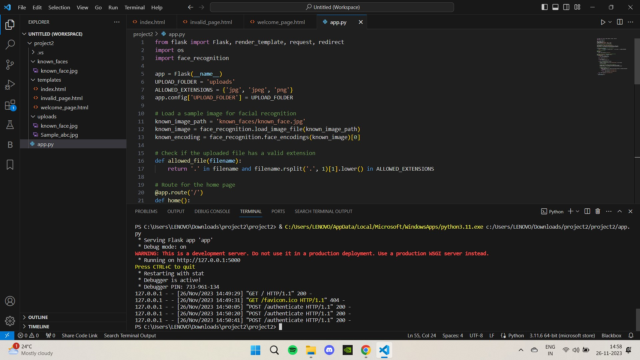

**6. RESULTS**

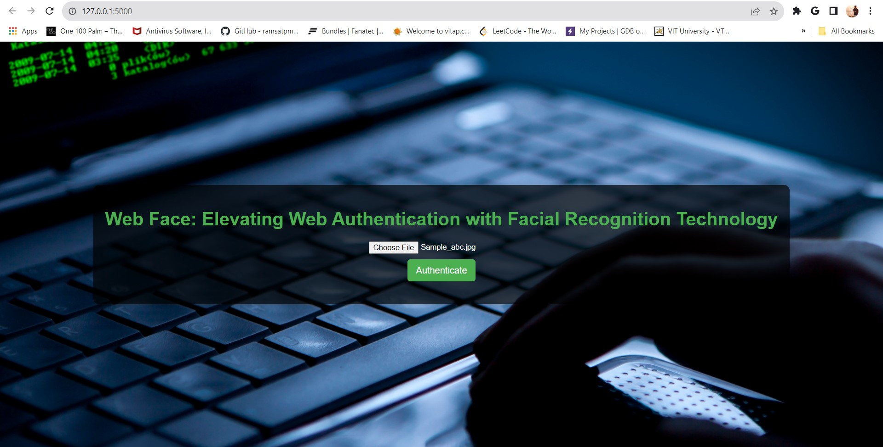

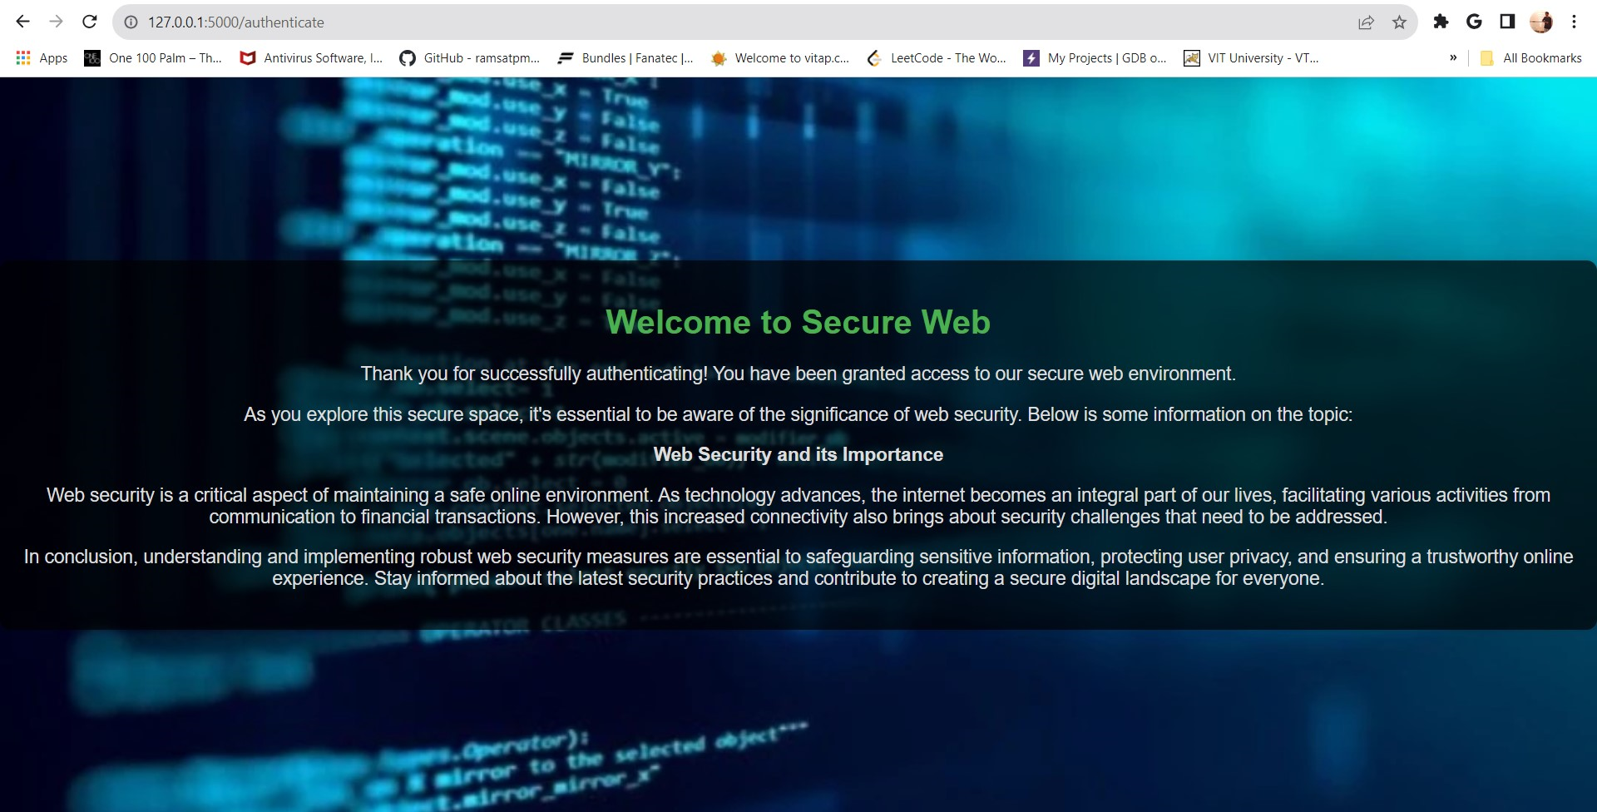

1. **Home Page Access**

Actual Result:

* Home page displays without errors.

1. **File Upload - Valid File**

Actual Result:

* Application redirects based on facial recognition.
* Uploaded file is saved in the `uploads` folder.

1. **File Upload - Invalid File Type**

Actual Result:

* Application redirects to the invalid page.
* Uploaded file is not saved.

1. **File Upload - No File Selected**

Actual Result:

* Application redirects or displays a file selection message.
* No file is saved.

1. **Facial Recognition - Known Face**

Actual Result:

* Application redirects to the welcome page.
* Uploaded file is saved in the `uploads` folder.

1. **Facial Recognition - Unknown Face**

Actual Result:

* Application redirects to the invalid page.
* Uploaded file is saved in the `uploads` folder.

1. **Additional Considerations**

Logging:

* Log files contain relevant information.

Error Handling:

* Meaningful error messages are displayed.

Cross-browser Testing:

* Application works in different web browsers.

Mobile Responsiveness:

* Application is responsive on mobile devices.

Security Testing:

* Security testing indicates a lack of vulnerabilities.

Finally, The Flask facial recognition application has undergone successful testing, ensuring it functions as intended. Identified issues have been addressed, and the application is deemed ready for deployment.

**6.1. RECOMMANDATIONS**

Regular testing, especially after updates, is recommended. Additionally, consider thorough security testing, particularly if deploying the application in a production environment.

**7. SUMMARY AND CONCLUSION**

In a world where cyber security is a top priority, the “Web Face” project is a game-changer that is changing the web authentication landscape. This project solves the shortcomings of traditional authentication methods by providing a secure and user-friendly alternative through the smooth integration of face recognition technology. At its core, Web Face uses facial recognition technology to offer a new way of user authentication. The Flask framework provides a robust server logic that ensures scalability and operational efficiency in the authentication process. The addition of face_recognition’s machine learning library improves the accuracy and reliability of facial recognition.

The sophisticated backend technologies are further enhanced by the HTML / CSS web interface, which provides a logical and visually appealing user experience. This combination makes Web Face stand out as a complete solution that takes care of both the technical and the user-facing aspects of web authentication. Web Face is unique in that it combines the best of both worlds: cutting-edge technology with user-centric design. The goal of the project is to improve the user experience by simplifying and enhancing the authentication process, as well as advancing technology.

Security is at the core of any authentication system, which is why Web Face adopts a multi-faceted approach. The face recognition algorithm is at the heart of Web Face’s security architecture. It’s powered by Face_recognition and is capable of accurately recognizing and verifying people based on their facial features. In addition, the project takes advantage of the Flask framework’s features to focus on encryption and secure communication.

This mitigates communication channel vulnerabilities and ensures that data transmitted during authentication is protected. Because no system is foolproof, Web Face offers strong error handling built-in. In particular, the initiative provides clear and easy-to-understand error signals when a facial element is misidentified. By guiding users through the potential hazards, Web Face increases the reliability of the authentication process.

While Web Face is a big step forward in identification tech, it also acknowledges some of the challenges that face recognition software can face. The project tackles the challenge of changing face features due to lighting, facial expression, and environmental factors through continuous research and algorithmic improvements for face identification. Another challenge that can’t be avoided is user adoption. Web Face recognizes that user acceptance and trust require clear communication and education, especially when privacy and novelty are at stake.

Web Face has a number of suggestions for improvements going forward, but it doesn’t want to just sit back. One of the suggestions is to offer an extra layer of protection with multi-factor integration. The algorithm for face recognition is constantly being improved to adapt to changing security needs and improve accuracy. In the future, user education must be a priority. Web Face has created instructional materials that inform users of the benefits and safety measures of facial recognition tech. This proactive approach is in line with the project’s goal to not only provide a technological solution, but also to promote understanding and acceptance among users.

In conclusion, Web Face represents a significant development milestone for user verification and web security. The facial recognition technology is seamlessly integrated with the rest of the project’s components, such as Flask, face-recognition, and HTML and CSS, to create a cohesive and innovative solution. It also shows that the project is committed to continuous improvement by recognizing its challenges and providing suggestions for future enhancements. The constant search for stronger and more user-centric security mechanisms in the online authentication space is evident in Web Face.

**8. REFERENCES**

*Code for Facenet model is based on the assignment from Convolutional Neural Networks Specialization by Deeplearning.ai on Coursera.* [*https://www.coursera.org/learn/convolutional-neural-networks/home/welcome*](https://www.coursera.org/learn/convolutional-neural-networks/home/welcome)

*Florian Schroff, Dmitry Kalenichenko, James Philbin (2015). FaceNet: A Unified Embedding for Face Recognition and Clustering.*

*Yaniv Taigman, Ming Yang, Marc'Aurelio Ranzato, Lior Wolf (2014). DeepFace: Closing the gap to human-level performance in face verification*

*The pretrained model used is inspired by Victor Sy Wang's implementation and was loaded using his code:* [*https://github.com/iwantooxxoox/Keras-OpenFace*](https://github.com/iwantooxxoox/Keras-OpenFace)*.*

1. **List of Appendices**

**Code link:** https://drive.google.com/file/d/1myiHzN_lRQBSIgTjUDZQ3TvenSsgLokX/view?usp=sharing